# Creating a Story with ScriptEase II

The goal of this tutorial is to create a story for your world. We already completed the first step in the last tutorial, but this tutorial will add on that using Story Points and Story Groups in the story graph.

We will add two more Story Points to our story. The player will be able to retrieve the rum for the Captain from the Captain’s Quarters. We will start by creating a custom “Rum” item.

After completing this tutorial, you will have a better understanding of creating custom objects in Aurora, and how to use the story system in ScriptEase II.

## **Getting Started:**

1. Create another backup of TreasureIsland.mod as in the previous tutorial. Also make a backup of the ScriptEase II story file with a “.ses” extension generated by ScriptEase II in the same way.
2. Close ScriptEase II if it is open and then open the module in Neverwinter Nights.

## Creating an Item:

1. You’re supposed to fetch the rum in the Captain’s Quarters, but there isn’t any rum there yet! Let’s add some. If you look for rum in the  “Items” palette, you won’t have any luck, even if you try to use the search feature by pressing Ctrl+F. Instead, we need to create our own item.
2. Under the “Items” palette, change the view to the “Custom” filter and expand the “Miscellaneous” category. Right click on any subcategory and click “New”.
3. In the “Item Wizard” that pops up, select “Potion Bottle” as the Item Type then click next.
4. Enter “Rum” as the name in the next screen and click next again.
5. In the next screen, select the “Plot Item” category then click next. On the next screen click “Finish.” You have just created your own item! This can be used like any other Game Object.
6. Drop the item in the middle of the Captain’s Quarters so that it is obvious to enterers.

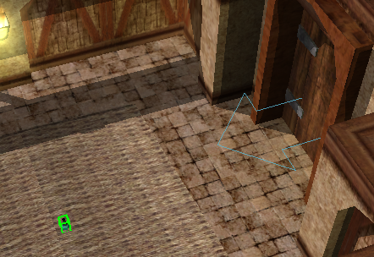

## Adding Story Points:

1. Save and close the module and open your story in ScriptEase II. The “Rum” item should appear in the Game Objects pane under Item.
2. Before we script the rum, we need to add some structure to our story. Let’s start by adding two story points to the story graph. Story points represent progression in the story. Right now we only have one called “Treasure Island”. We need to add story points for when the rum is acquired and given to the Captain.

Tip:The first Story Point cannot be removed.

1. Click on the Add Story Point toolbar button to change the tool in the graph. Click on the “Treasure Island” Story Point, then again on the “New Story Point” to create two new Story Points. Change back to the selection tool represented by a mouse pointer so that you do not accidentally add another Story Point.

Tip:There are four other tools in the toolbar. The red trash bin icon will delete Story Points and ungroup Story Groups. The next two allow you to connect and disconnect Story Points. The last icon allows you to group Story Points together. You will be exposed to Story Groups and all these tools as the tutorials progress.

1. Rename the first “New Story Point” by clicking on the title and entering “Rum Acquired”.
2. Rename the next “New Story Point” to “Rum Retrieved”. (Figure 1)



Figure 1

## Story Progression and Journals:

1. The story graph represents the progression of your story as the game is played. When you start playing the game, only the first Story Point is active. As you successfully complete the first Story Point, subsequent Story Points become active. Before we add any causes to these new Story Points, we need a way to get to them by making the first Story Point succeed. Select the “Treasure Island” Story Point.
2. In the “When <Alright, be right back> is reached” cause, add the “Succeed Current Story Point” effect after the last effect in the “Current Active” Yes section. (Search for the word “succeed” in the effects pane on the top left, then drag the effect over.) The Succeed Current Story point is a special effect which handles story progression without user input. There is another effect called “Succeed <Story Point>” which accepts any story point from the graph, but for ease of use we use “Succeed Current Story Point” to prevent organizational errors.
3. Drag the green (SP) “Treasure Island” Story Point Widget from the graph into the effect’s slot (Figure 2).

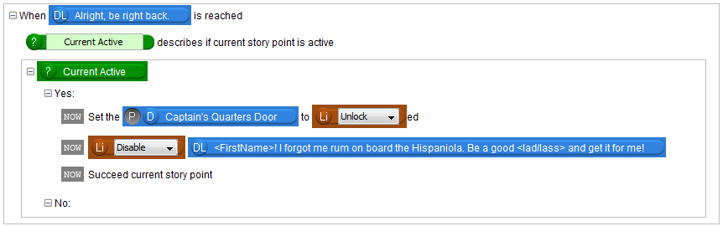Figure 2

Tip:Any effects in Yes section of the “Current Active” question only happen when the story point is active. When we succeed a story point, the story point becomes inactive and the story point(s) immediately after it become active instead.

Tip:Remember: In order for effects to happen regardless of whether the story point is active, they need to be directly in the cause, not inside “Current Active”

1. Neverwinter Nights also has a journal system that lets the player check where they are in the story by pressing “J”. Each journal has a series of Journal Records that serve as categories. Each quest usually has its own record. A record has a sequence of Journal Points, which are lines of text that tell the player where they are in the story.

Warning: Do not use the Journal editor in Aurora when using SEII; SEII provides an easier way to manage journals. Journals created in Aurora will be overwritten!

1. To add a journal record, drag the effect “Add Journal Record for Story Point” into the Yes section of the “Current Active” question, before the “Succeed Current Story Point” effect. From the Story Graph, drag Treasure Island into the slot. The Record will inherit the name from this Story Point.
2. We need to add a Journal Point to the Record. The Record won’t show up unless it has a Journal Point in it. Drag in the “Add Journal Point to Journal Record of Story Point with text” effect right below the Add Journal Record effect.
3. Drag the Treasure Island story point into this effect and write “I should go get the rum from the Captain’s Quarters” in the text field (Figure 3). You may test your game at this point.

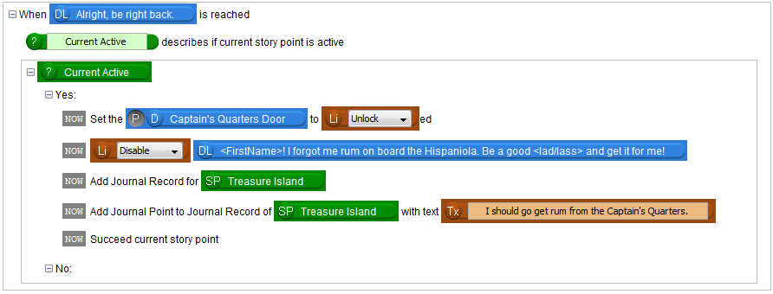Figure 3

## Description Graphs:

1. Select the Rum Acquired story point by clicking on it in the graph. The bottom of the screen will update to show this point’s causes and effects, which will be empty.
2. Let’s add a cause. We want this Story Point to succeed when we retrieve the rum. We also want to move the Captain’s conversation to the next node. Drag in the Cause called “When Acquirer acquires Acquired Item with…”
3. Since this fires when any item is picked up, we need to add a check that makes sure the item is the Rum. Otherwise, the Story Point would succeed if we picked up something completely different, like a rock. This requires a Description from the top left Descriptions tab.
4. Drag in a description to check for the Rum item, called “Objects are Equal describes if First Object is Second Object” into the Yes section of the “Current Active” section.
5. This description is a bit different than the Player Character description since it has an expansion button: . Click on this button to display a graph. Selecting a valid path in the graph allows us to change the meaning of a description.
6. In this case, select the path “If First Object is Second Object” by clicking on “is” then on the last node (Figure 4). Then click the minus button to the left to close the graph. (For your reference, it is possible to have two different objects with matching blueprints or tags, but here we want to make sure the two objects are actually the same object.)

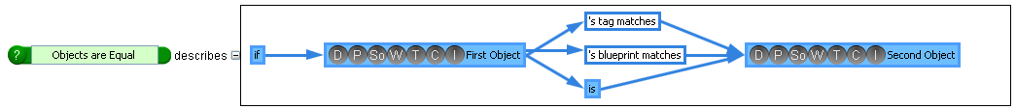

Figure 4

1. The text in the description will change. Drag the Rum item into the First Object slot.
2. The Second Object will be whichever item was acquired. If you look at the Cause, you will see some green objects. We can see that the Acquired Item is one of these, so let’s drag that into the Second Object slot (Figure 5).

Tip:The green objects are called **Implicits**. An Implicit is a game object that is determined by the cause. In this case, the implicits tell us who acquired the item, which item was acquired, and more.



Figure 5

## Questions:

1. To use the Objects are Equal object created by the description, we need a special story component called a “Question”. This is in the only tab we haven’t touched yet, the “Controls”. You will notice that there is a “Blocks” tab but since there aren’t any for the Neverwinter Nights translator, we don’t need to worry about it. Click on the “Controls” tab in the Library pane now. Drag the question into the Yes section of the “Current Active” question just like any other effect, then drag the Objects are Equal object into the slot.

Tip:The question object we dragged in asks the question, “Is Rum the Acquired Item?” If the answer is yes, any effects in the “Yes” section of the Question controller will happen. Otherwise, the effects in the “No” section will happen.

1. We are only concerned with the Yes section of the new question for now. Drag in a “Disable dialogue line” effect into the Yes section of “Objects are Equal” and then drag the “You’re back! But where is me rum?” dialogue line into the slot.
2. Let’s update our journal. Drag an “Add Journal Point to Journal Record of Story Point” effect. Remember that we created the Journal Record for the Treasure Island Story Point, so we need to use that Story Point again to access our record. Drag Treasure Island into the Story Point slot. In the text box, write “I found the rum. I should go back to the Captain.”
3. We need to advance the story again. Drag in a “Succeed Current Story Point” effect under the previous effect. Drag the Rum Acquired Story Point object into the slot (Figure 6).

Tip:Effects added after a “Succeed Current Story Point” effect will still fire before the story moves onto the next Story Point.

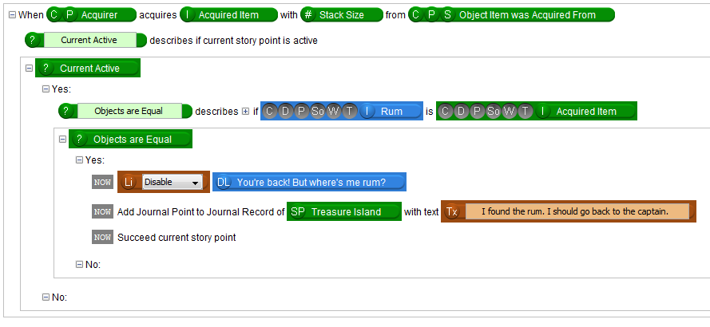Figure 6

1. Save and test the module.

## Destroying Multiple Objects at Once:

1. The Captain will now let you know that you should get some treasure if you talk to him. However, the path to the cave is still blocked. We should make the Captain say something different again. Make sure that the “Rum Retrieved” Story Point is selected, then add the “When subject is reached” cause to the “Rum Retrieved” Story Point and drag the “Ah that hits the spot…” dialogue line into the subject slot.
2. Let’s animate the Captain to drink the rum when we return it to him. Drag an “Animate Creature to Animation” effect into the Yes section of the “Current Active” question. Drag the Captain Silver object into the Creature slot, and change the animation to “Drink”.

Tip:The slot also accepts a few other types. You could destroy all objects with the same tag as a Creature, Door, Item, or Trigger.

1. We wanted to get rid of all of the trees, so find another effect called “Destroy all objects with same tag as The Object”. Remember how I mentioned that every Large Tree has the same tag? This makes it possible for us to use this effect. Drag the Large Tree object into the slot.
2. Disable the “You’re back with me rum” dialogue line with the appropriate effect. Add it below the previous one.
3. Succeed the Rum Retrieved Story Point with the appropriate effect.
4. Also add another Journal Point that says “I gave the Captain his rum. He told me to go look for Treasure in the cave.” Your Cause should look like the following screenshot. Remember that the Story Point of the Journal Record is Treasure Island, not Rum Retrieved (Figure 7)!

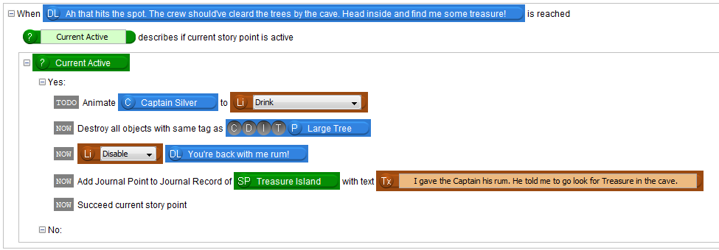

Figure 7

1. Save and test your story.

You now know the basics of using the story system. Although you could add all causes and effects into one Story Point, the story system makes it easier to organize your stories. There is also some automatic functionality with the Yes section of the “Current Active” question which we will go into more detail in the next tutorial.

If you want to go even further, add a pirate with an axe by the trees that changes his conversation based on where you are in the story. You could also see if there is an effect to remove the rum from your inventory when you give it to the Captain. Try destroying it to remove it from the inventory.

Advanced: **A Note on Equivalent Causes:**   
Say you add two of the same cause and use the same objects as the slot, for example “When Captain Silver is damaged”. These causes would be **equivalent**.

You may get some unintentional behaviour if:

1. The two equivalent causes are in two adjacent Story Points. If you succeed the first Story Point in the first Cause, the effects in the second Cause will also happen!
2. The two equivalent causes are in the same Story Point. Succeeding the Story Point inside of one of their blocks may cause the other’s effects in the Yes section of the “Current Active” question to not happen at all.

This happens because ScriptEase II combines the causes together before creating Neverwinter Nights scripts out of them. It then checks whether a Story Point is active before firing the effects inside of that point.  
  
If you want to avoid A, you could add a Story Point in between the two adjacent Story Points and only add in a “When Story Point is activated” cause and drag in the “Succeed Current Story Point” effect into the Yes section of the “Current Active” question. Since the latter Story Point will not be active when those effects are checked, they will not happen. To avoid B, you should make sure to only have one of these equivalent causes in each Story Point.

## Creating a Story Group:

1. Story Groups are a way to group together Story Points using the Group C:\Documents and Settings\TEMP.UOFADOCS\Desktop\gorup.png Tool. The biggest usability for them is to group together many Story Points to reduce clutter on the screen. You can minimize and expand Story Groups to hide and reveal their contents.
2. Experiment by grouping together the “Rum Acquired” and “Rum Retrieved” Story Points.

Start by selecting the Group Tool then click on the “Rum Acquired” Story Point. You will notice that the “Rum Acquired” Story Point turns to a bluish teal colour. This signifies that a group is in the process of being created, but you cannot create the group yet since in this case there is only one Story Point. Click on the “Rum Retrieved” Story Point and you will notice the Story Points turn green. This signifies that a group can be created. Right click on either of the two Story Points to form the group. Experiment with minimizing and expanding the group. You cannot add or delete Story Points with a group. You can, however, select and modify their contents.

1. To ungroup the Story Group, select the trash icon. You will notice that when hovering over a Story Group, the icon changes to an ungroup icon. Click the group to ungroup it. Since two Story Points do not take up too much space, we will leave them ungrouped for this tutorial’s purpose.

Tip:Not all Story Points can be formed into a group. First of all, a Story Group must contain more than one Story Point. Secondly, there is at most one exit Story Point and one entrant Story Point.  This means that all Story Points that come before the group must come before the entrant Story Point (the first Story Point you click). Similarly, all Story Points that come after the group must come after the exit Story Point.